CSC 235

Introduction to Linux & Linux Administration

Fall 2025

**Assignment #2: Linux CLI**

**Assigned: Tuesday, September 2, 2025**

**Due: Sunday, September 7, 2025 (NLT 23:59)**

**Instructions:**

1. Insert your answers into this document (*text and screenshots*)
2. Highlight your answers in green (*text only*)
3. When finished, rename the document (*please use the naming convention below*)
4. Upload the renamed document to the Moodle assignment

**A2 - Last Name** (e.g., **A2 - Nonnweiler**)

**Exercise I**

Navigate to your home directory and create a subdirectory named **Sales**, then move so that your current working directory is the Sales directory.

1.1. Take a screenshot showing your location within the file structure.

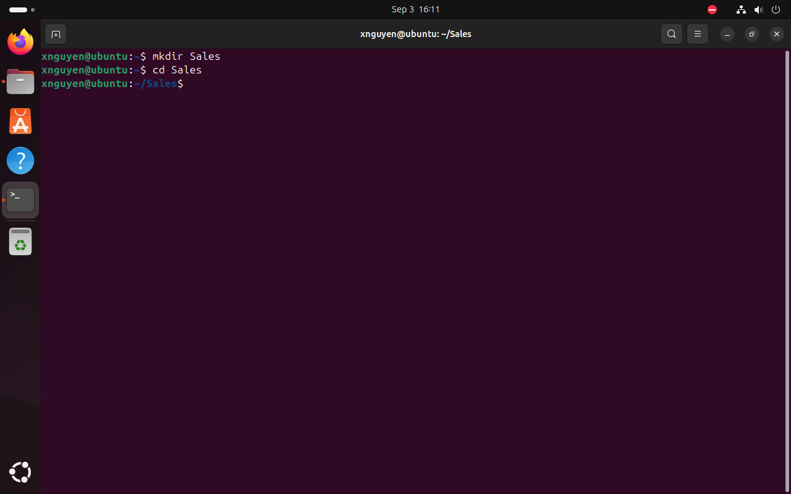

1.2. List the commands that you used to accomplish this task.

Answer:

mkdir Sales

cd Sales

Create a new file named Sales.date in the Sales subdirectory by directing the output of the Date utility to the file. Next, append the Sales.date file with the current month calendar

1.3. Verify your previous work by taking a screenshot of the **cat** command on the **Sales.date** file.

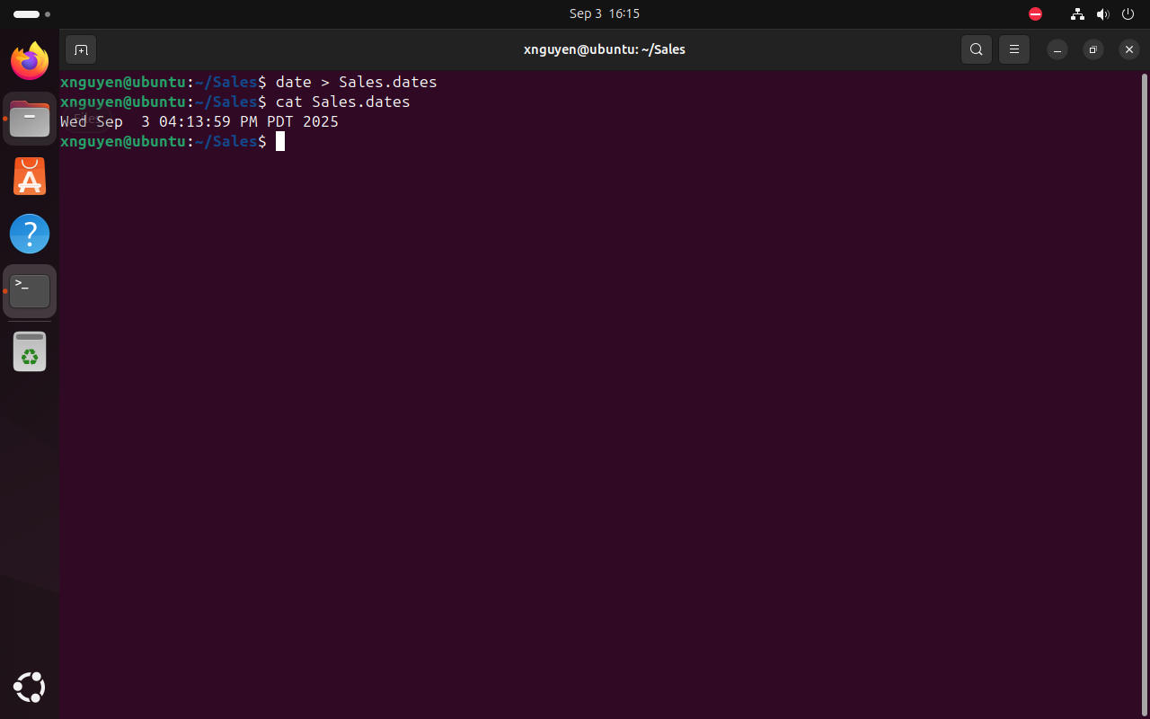

**Exercise II**

Create the following files in your home directory with the following content:

**Filename File Content**

**Car_Insurance** All current online users

**Travel_Insurance** Current date

**House_Insurance** February 2024 calendar

**Life_Insurance** List of all files in the current directory

**Health_Insurance** List of all processes associated with your login account

2.1. Take a screenshot showing the contents of **Car_Insurance**.

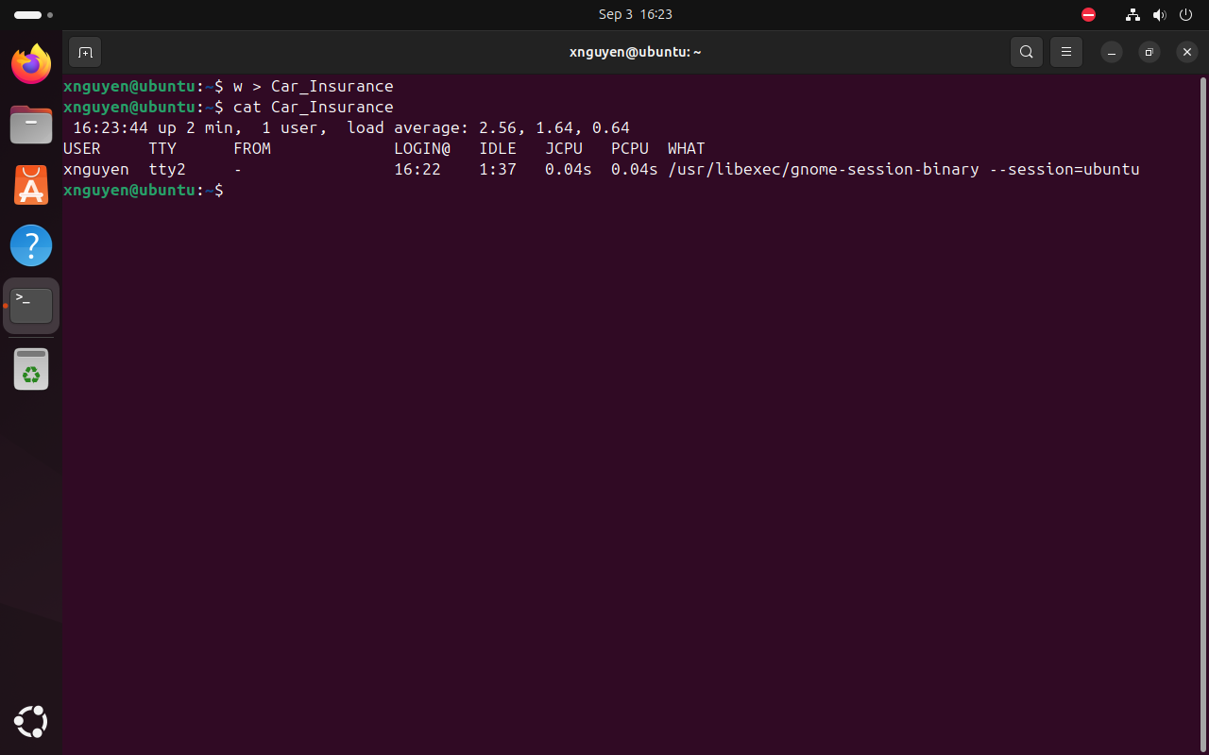

2.2. Take a screenshot showing the contents of **Travel_Insurance**.

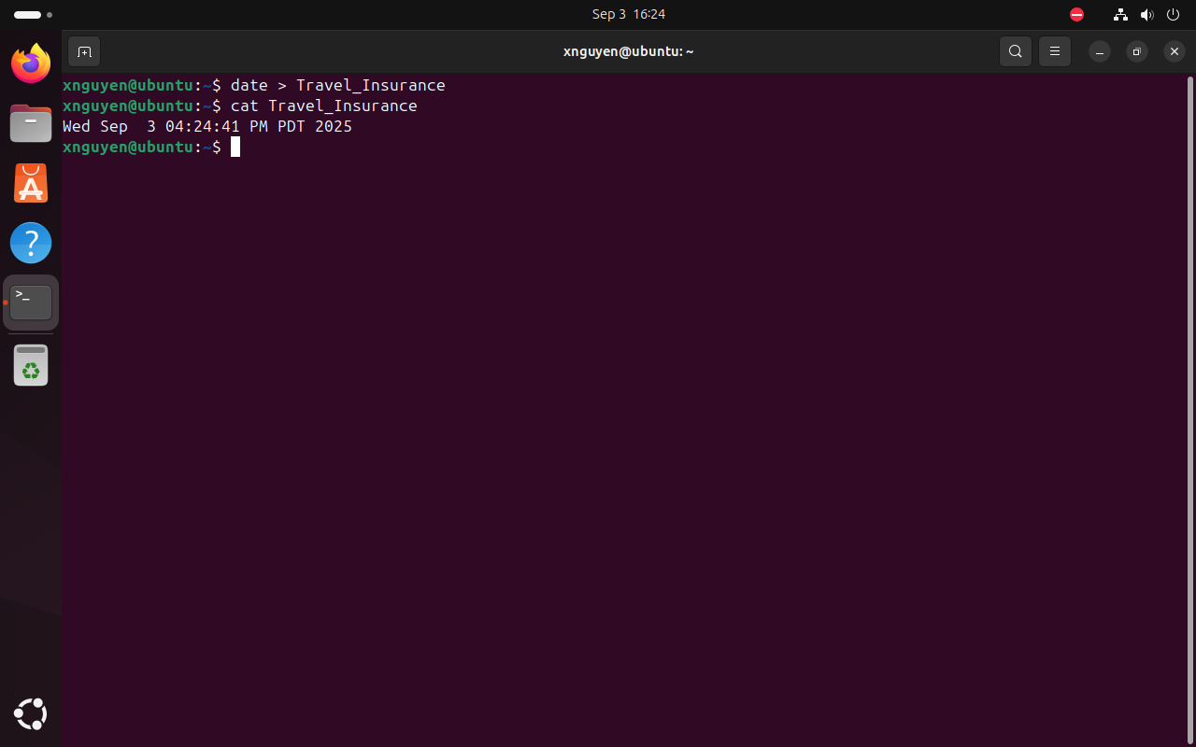

2.3. Take a screenshot showing the contents of **House_Insurance**.

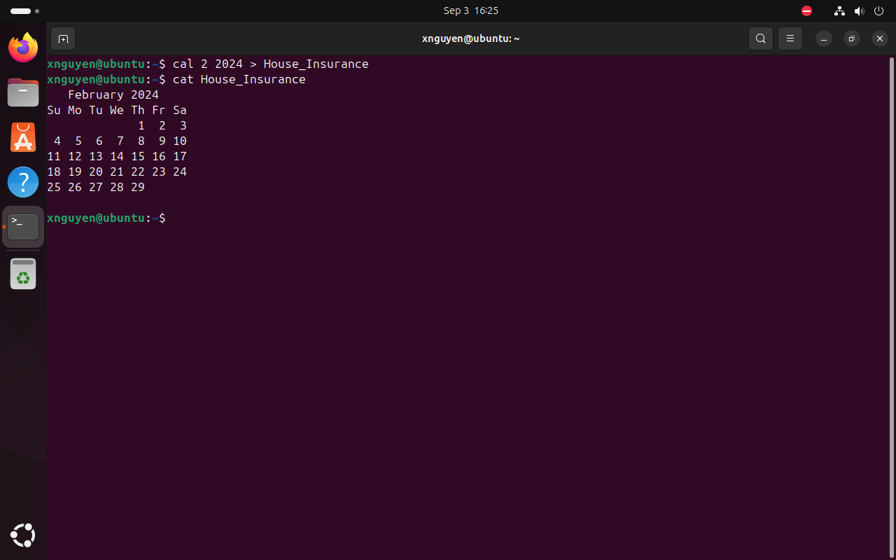

2.4. Take a screenshot showing the contents of **Life_Insurance**.

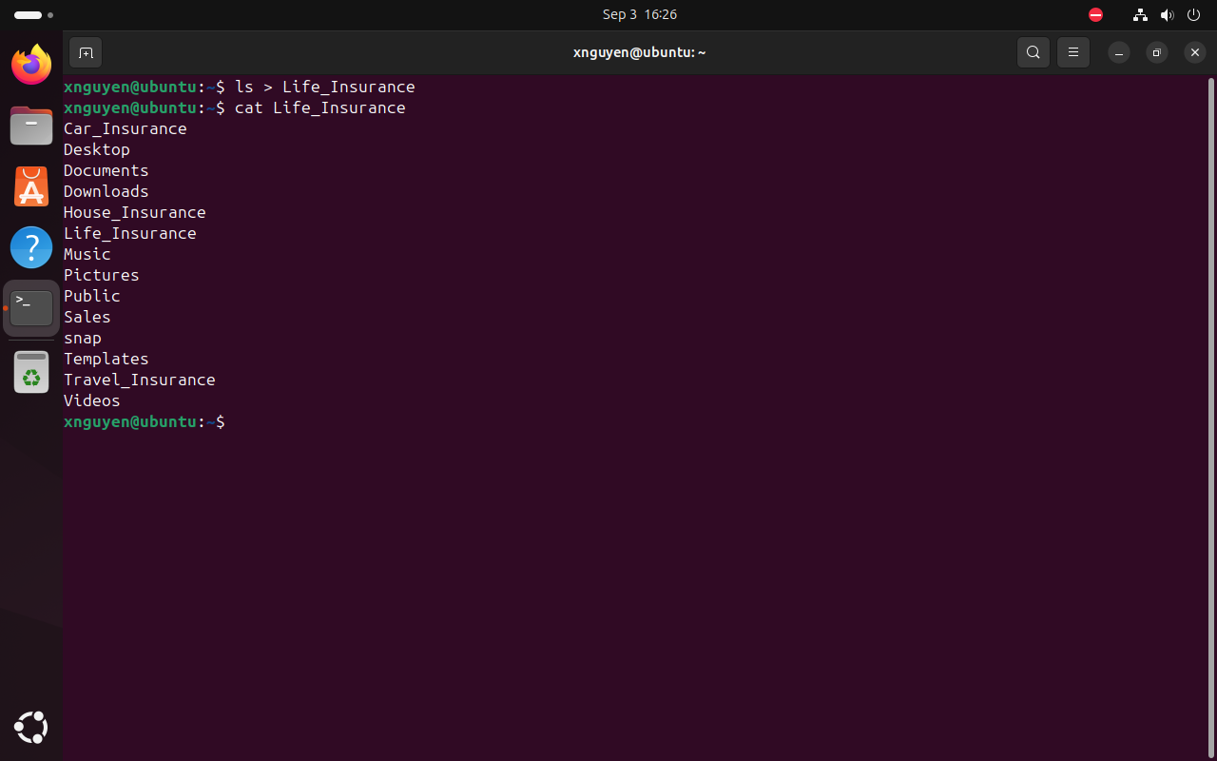

2.5. Take a screenshot showing the contents of **Health_Insurance**.

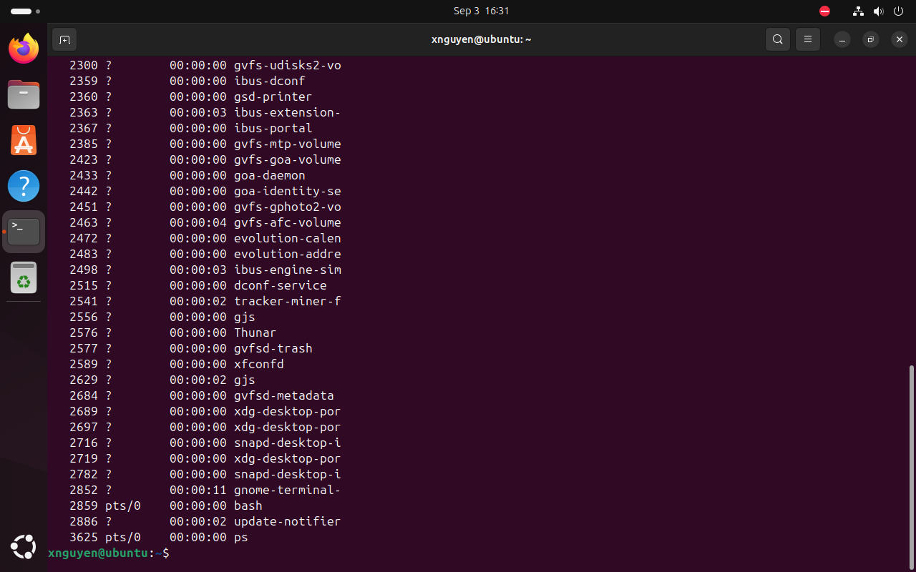

Copy the **Car_Insurance** file to the Sales subdirectory that you created above. Next, rename the **House_Insurance** file to **House.** Lastly, remove the **Health_Insurance** file with a confirmation. What is the argument used to prompt a confirmation?

2.6. Answer: -i

Verify your previous work by taking a screenshot of the directory list command for your a.) home directory and the b.) Sales subdirectory.

2.7. a.) home directory

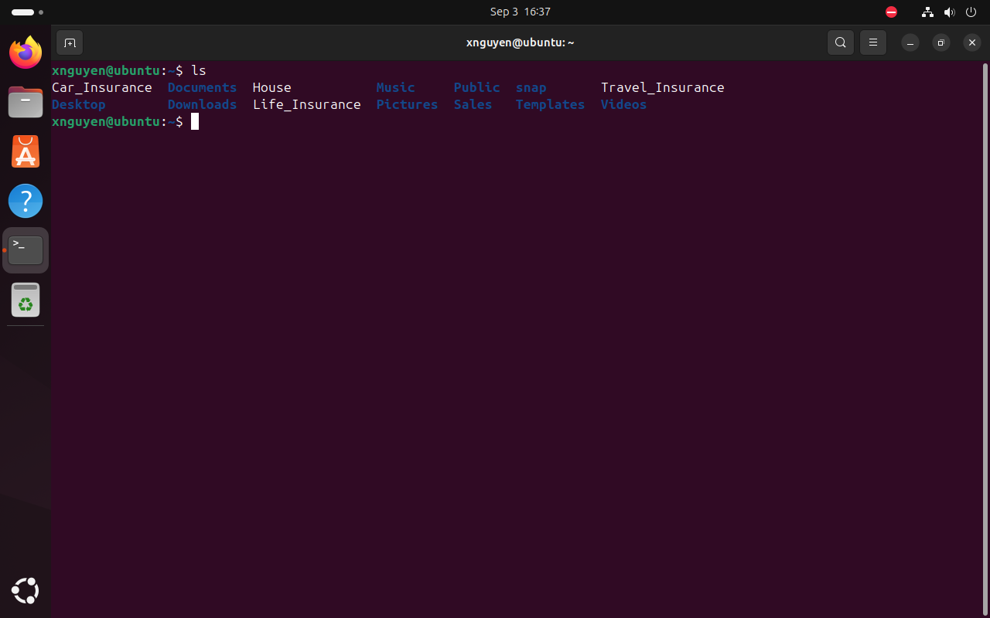

2.8. b.) Sales subdirectory

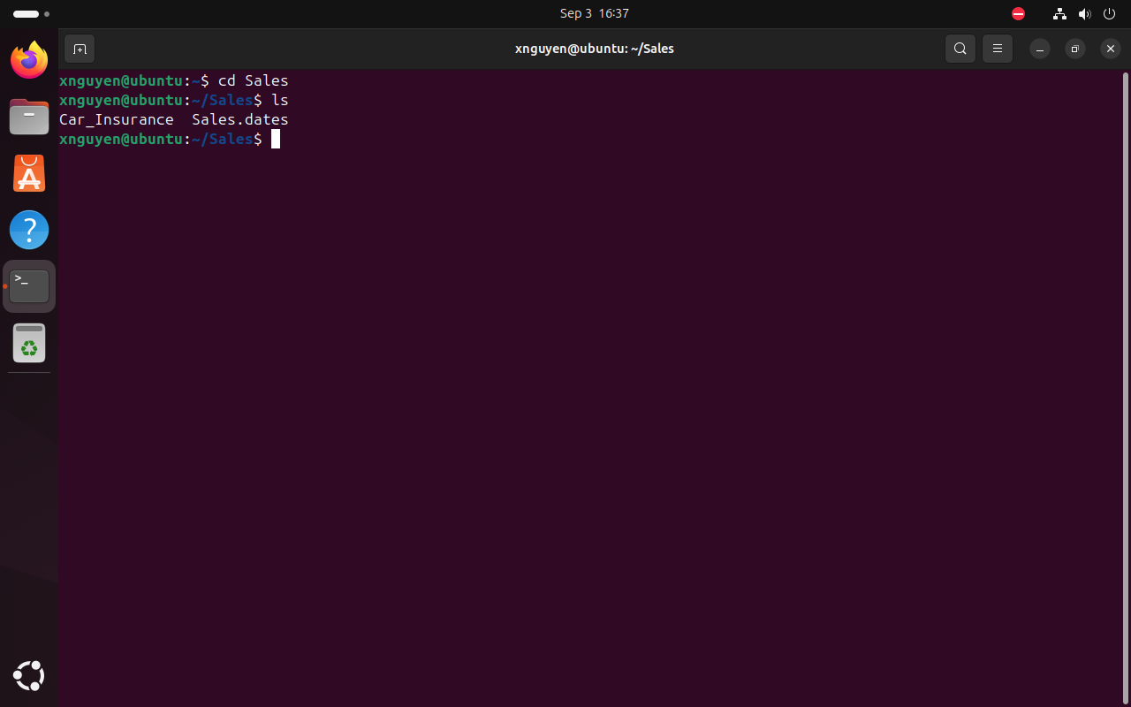

2.9. Attempt to print the **Life_insurance** file to a printer that you specify. (*Note: sending a file to a printer is not covered in the first two sections of TestOut. Check out man -k print*). What command did you use? What message did you receive?

Answer: lp –d printer Life_Insurance; lp: Error – The printer or class does not exist.

**Exercise III**

Create the following chapter files of your sci-fi book you are writing in your home directory with the content provided:

Chapter_1 It was a dark and stormy night.

Robbie unsuccessfully tried to block out the sounds of the thunderstorm so that Gloria would not wake up.

Chapter_2 Robbie looked at his watch.

It was too late.

Chapter_3 The sun was setting but Powell didn’t care.

3.1. Take a screenshot that shows the output of the utility used to show the number of lines, words, and characters for the three files.

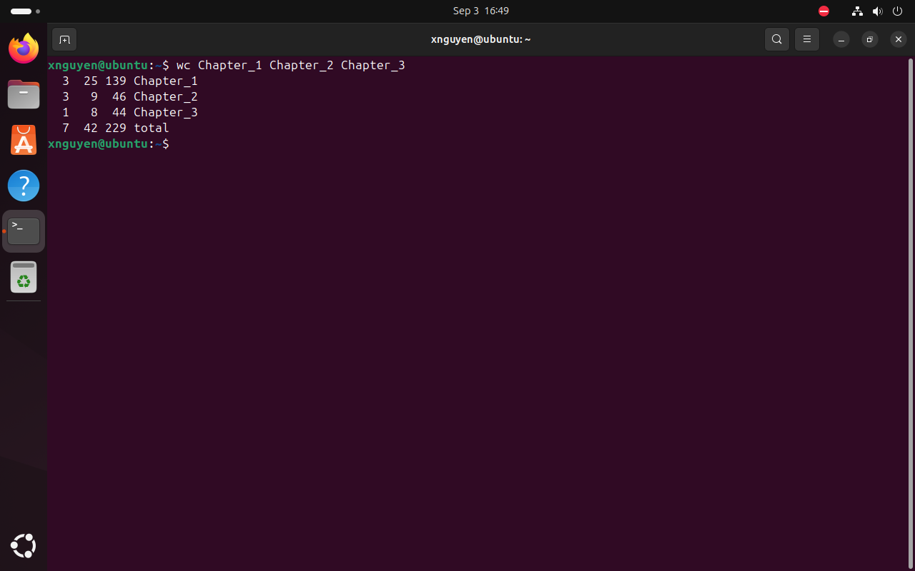

Create a file in your home directory named **ChapterList** that lists the names of the first three chapters in your home directory. Sort the file in reverse order and display the results. (*hint: ls, grep (-e), sort (-r), piping, redirection*)

3.2. Take a screenshot of the cat command performed on **ChapterList**.

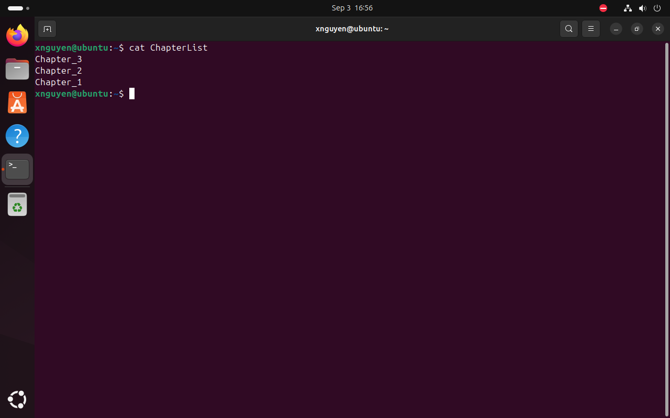

3.3. List the one-line multi-command you used to create the desired result.

Answer: ls ~ | grep -e '^Chapter_[1-3]$' | sort -r > ~/ChapterList && cat ~/ChapterList

3.4. Locate the word *thunderstorm* in the appropriate chapter by employing the correct utility command at your terminal home directory. Locate the word *storm*. Do your results differ? Why or why not.

Answer: The results differ because “thunderstorm” shows up once in Chapter 1, while “storm shows up twice in Chapter 1.

3.5. Display your commands and output.

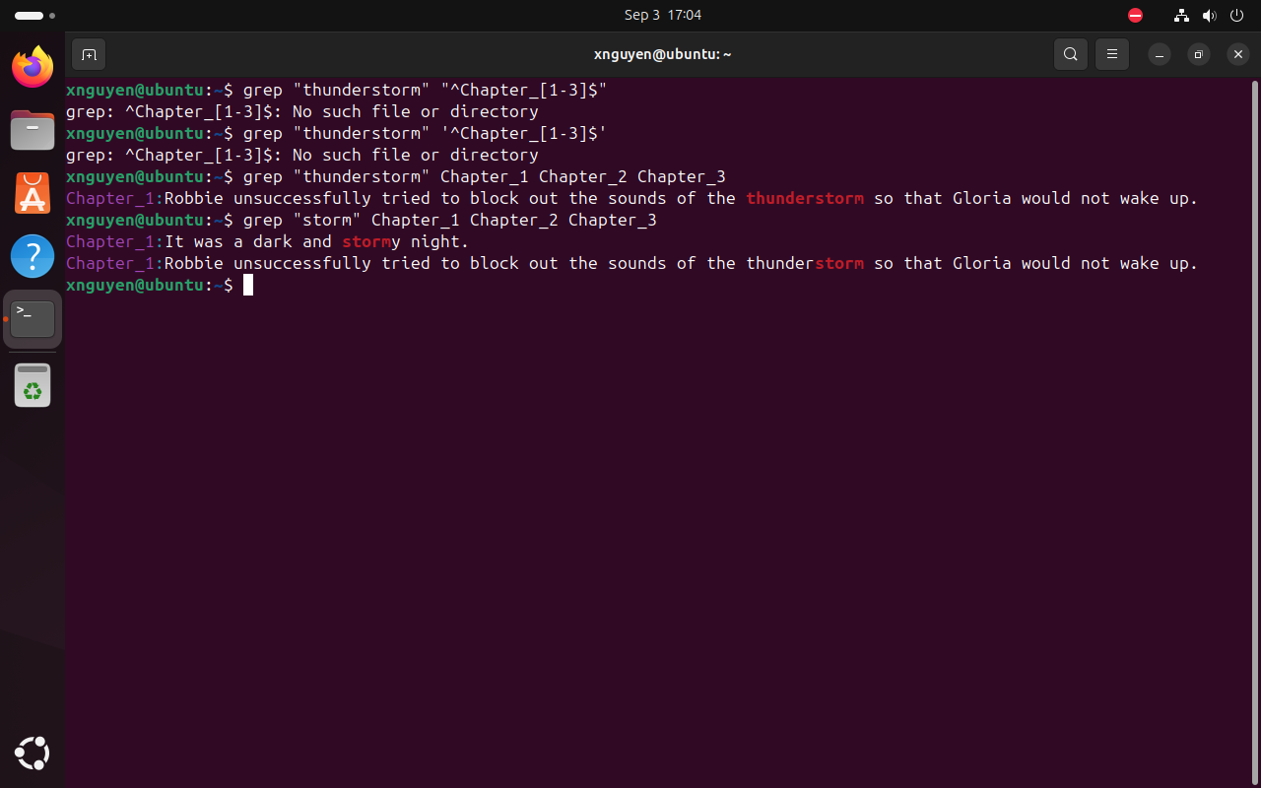

3.6. You want to check how the chapters flow together; create a file named **my_scifi** that is a concatenation of the three chapter files. Display the contents of **my_scifi** on your screen to show it contains the text of all three files. Ensure that the command you used to merge these files is visible.

